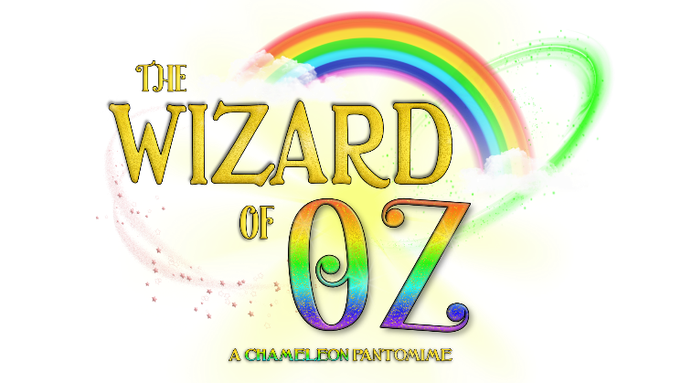

*The Wizard of Oz* Cast Details Form

|  |  |
| --- | --- |
| Name: |  |
| Preferred Name/Pronouns: |  |
| Date of Birth: |  |
| Parent/Guardian Names: |  |
| Contact Number: |  |
| Contact Email: |  |
| The performance of *The Wizard of Oz* will take place on Saturday 6th December 2025 at the Cygnet Theatre. I know that I/my young person can be available for this date. | Yes/No |
| Rehearsals for *The Wizard of Oz will run from* Saturday 6th September to Saturday 6th December 2025*.*  Please state any dates you are unable to make in the attached rehearsal schedule at the end of the form. | |

Rehearsals will be held **10:30am-12:30pm** at **Exeter Community Centre, St Davids Hill, EX4 3RG**. The final performance will be held at the **Cygnet Theatre**, Exeter on **Saturday 6th December**. Cast are required to be available for the entire day of the performance to allow for a technical rehearsal in the morning.

The total cost to be involved in the project is £140. If you have more than one child attending and would like to spread out the costs further, please speak to Jake ([jake.anthos-arts@outlook.com](mailto:jake.anthos-arts@outlook.com)).

|  |  |
| --- | --- |
| I agree to a payment of £140 for the full project.  Payment via BACS to:  *Anthos Arts*  *Account Number: 57329370*  *Sort Code: 600806*  Please note, full payment must be made by **Saturday 25th October.**  **PLEASE USE CHILD’S NAME AS A REFERENCE ON ANY PAYMENT. DO NOT MAKE PAYMENT UNTIL YOUR CHILD’S SPACE HAS BEEN CONFIRMED.** |  |

**Permissions and Emergency Contacts:**

As part of our safeguarding policy, Anthos Arts asks that parents of children and young people who attend our sessions have three emergency contacts whom we can contact in the event of an emergency. Participants over the age of 11 are permitted to leave rehearsals without an adult, however do require permission to do so. Children over the age of 11 travelling home alone are not permitted to take younger children home (any siblings must still be collected by an adult)

Please fill out the section below.

I am happy for my child to leave rehearsals without being accompanied by a nominated adult:

YES/NO (please circle/delete as appropriate.)

I ……………………………….. hereby give my consent for the following individuals to collect my child/children on my behalf from sessions and events in my absence.

Signature: Date:

Name of Nominated Person #1:

Contact Number:

Relation to Child:

Name of Nominated Person #2:

Contact Number:

Relation to Child:

Name of Nominated Person #3:

Contact Number:

Relation to Child:

Parents/Carers/Guardians are at liberty to disclose the names of anyone who they know are NOT allowed to collect children on their behalf. Anthos Arts are committed to supporting safeguarding and the safety of children and so please let us know if you wish to name any such persons.

**Known Medical Information:**

(Please list all known medical information in regard to your child/children attending the sessions*. Our primary first aider during sessions is Jake Celecia*.)

CONSENT:

I ………………………….. hereby consent to any First Aid or medical treatment necessary to be given to my child/children ………………………………………………………………………………………………… during rehearsals.

**Media and Publicity**

A part of Anthos Arts’ new success has been our media attention. Please sign below to show that you are happy for us to photograph/video your child and that your child is allowed to be a part of any media used within our publicity.

|  |  |
| --- | --- |
| I (parents/ guardians name)  ____________________________  allow my child ­­­­­­­­­­­­­­­­(child’s name)  ____________________________  to be photographed and videoed for use by Anthos Arts publicity. | Parent/ guardians signature |

Signed: Dated:

If there are any questions, then don’t hesitate to get in touch! Contact us with any queries you might have. Otherwise please return this completed form to [applications.anthos-arts@outlook.com](mailto:applications.anthos-arts@outlook.com).

Thank you for completing this form. We look forward to working with you.

*The Anthos Team.*

*Please state any dates you are unable to make.*

|  |  |
| --- | --- |
| Saturday 6th September 10:30-12:30 |  |
| Saturday 13th September 10:30-12:30 |  |
| Saturday 20th September 10:30-12:30 |  |
| Saturday 27th September 10:30-12:30 |  |
| Saturday 4th October 10:30-12:30 |  |
| Saturday 11th October 10:30-12:30 |  |
| Saturday 18th October 10:30-12:30 |  |
| Saturday 25th October 10:30-12:30 |  |
| Sunday 1st November 10:30-12:30 |  |
| Saturday 8th November 10:30-12:30 |  |
| Saturday 1st November 10:30-12:30 |  |
| Saturday 8th November 10:30-12:30 |  |
| Saturday 15th November 10:30-12:30 |  |
| Saturday 22nd November 10:30- 2:30pm |  |
| Saturday 29th November 10:30pm- 1pm-**DRESS** |  |
| Saturday 6th December 10am-4pm- **PERFORMANCE** |  |