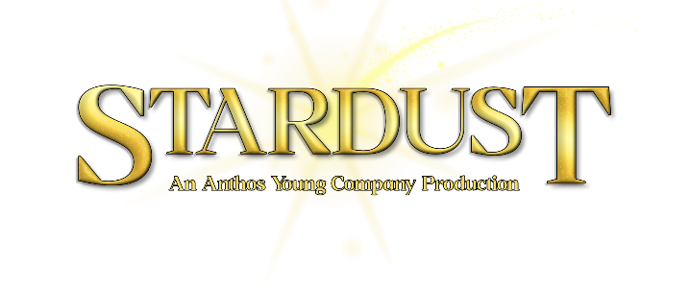
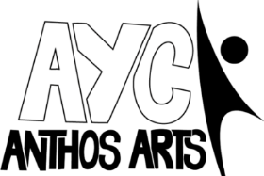
Stardust: Cast Details Form
Name:

Preferred Name/ Pronouns:

Date of Birth:

Parent/Guardian Names:

Contact Number:

Contact Email:

The spring term performance will be on Saturday 24th October. I know that I can be available for the whole of this day.

Rehearsals for spring term will take place on Saturdays from Saturday 2nd May to Saturday 24th October 2026, with a break over August. There will be some additional Sunday rehearsals closer to the performance. Please state any dates you are unable to make in the attached rehearsal schedule at the end of the form.

Rehearsals will be held 1-3pm at Exeter Community Centre, St David’s Hill, EX4 3RG. The final performance will be held at the Cygnet Theatre, Exeter on Saturday 24th October. Cast are required to be available for the entire day of the performance to allow for a technical rehearsal in the morning. Cast MUST also be available for the dress rehearsal on Sunday 18th October in order to participate in the show.
The total cost to be involved in the project is £200. If you have more than one child attending and would like to spread out the costs further, please let us know.
I agree to a payment of £200 for the full project. Payment via BACS to:

Anthos Arts
Account Number: 57329370
Sort Code: 600806

Please note, full payment must be made by Saturday 19th September 2026.
PLEASE USE CHILD’S NAME AS A REFERENCE ON ANY PAYMENT.
Permissions and Emergency Contacts:
As part of our safeguarding policy, Anthos Arts asks that parents of children and young people who attend our sessions have three emergency contacts whom we can contact in the event of an emergency. Participants under the age of 16 also require permission to leave rehearsals without being accompanied by an adult to travel home. Please fill out the boxes below.
I am happy for my child to leave rehearsals without being accompanied by a nominated adult:
YES/NO (please circle/delete as appropriate.)
I ….. hereby give my consent for the following individuals to collect my child/children on my behalf from sessions and events in my absence.

Signature: Date:

Name of Nominated Person #1:
Contact Number:
Relation to Child:
Name of Nominated Person #2:
Contact Number:
Relation to Child:
Name of Nominated Person #3:
Contact Number:
Relation to Child:
Known Medical Information:
(Please list all known medical information in regard to your child/children attending the sessions. Our primary first aider during sessions is Jake Celecia.)

CONSENT:
I …………… hereby consent to any First Aid or medical treatment necessary to be given to my child/children ……………………………… during rehearsals. I authorise supervising staff to sign any written form of consent required by the hospital authorities if the delay in obtaining my signature is considered by the doctor to endanger my child’s health and safety.
Media and Publicity
Please sign below to show that you are happy for us to photograph/video your child and that your child is allowed to be a part of any media used within our publicity. Please note, this is not mandatory and will not impact applications.
I (parents/ guardians name)  ________  allow my child (child’s name)  _____  to be photographed and videoed for use by Anthos Arts publicity. | Parent/ guardians signature
(Please include any notes about photography preferences here (for example; happy for your young person to be photographed but do not want photos shared on social media.)

SUMMER TERM REHEARSALS
Please state any dates you are unable to make.
Saturday 2nd May 1-3pm

Saturday 9th May 1-3pm

Saturday 16th May 1-3pm

Saturday 23rd May 1-3pm

Saturday 30th May 1-3pm

Saturday 6th June 1-3pm

Saturday 13th June 1-3pm

Saturday 20th June 1-3pm

Saturday 27th June 1-3pm

Saturday 4th July 1-3pm

Saturday 11th July 1-3pm

AUTUMN TERM REHEARSALS
Please state any dates you are unable to make.
Saturday 5th September 1-3pm

Saturday 12th September 1-3pm

Saturday 19th September 1-3pm

Saturday 26th September 1-3pm

Saturday 3rd October 1-4pm

Sunday 4th October 11:30-15:30

Saturday 10th October 1-4pm

Sunday 11th October 11:30-15:30

Saturday 17th October 1-5pm
DRESS REHEARSAL

Saturday 24th October 10am-8pm-
PERFORMANCE DAY

Signed: Dated:
If there are any questions, then don’t hesitate to get in touch! Contact us with any queries you might have. Otherwise please return this completed form to applications.anthos-arts@outlook.com.
Thank you for completing this form. We look forward to working with you.
The Anthos Team.

