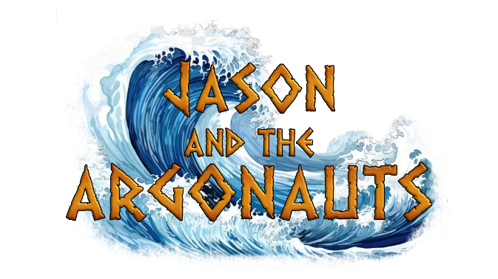

‘JASON AND THE ARGONAUTS’ –
Chameleon Group Application Form Summer 2024

Participant Details:
Name:

Preferred Name/Pronoun:

Date of Birth:

Address:

Parent/Guardian/Primary Carer Names:

Contact Numbers:

Contact Emails:

The performance of Jason and the Argonauts will be on Sunday 30th June. I know that my child/children can be available for this date. | Yes/No

Permissions and Emergency Contacts:
As part of our safeguarding policy, Anthos Arts requires children to have nominated people who are permitted to collect them from us at the end of each session/trip/event.
Below please list the names of nominated adults who have permission to collect your child on your behalf. A nominated person must be over 18 years of age and grandparents must be listed as nominated people, if parents wish to name them as such. Note: children will not be allowed to leave a session with an adult not listed on their form without written consent. Should a different person than those listed on this form be required to pick a child up then this must be arranged in advance of the session in writing.
Those nominated shall serve as emergency contacts, should we be unable to contact primary carers in the event of an emergency.

Name of Nominated Person #1:
Contact Number:
Relation to Child:
Name of Nominated Person #2:
Contact Number:
Relation to Child:
Name of Nominated Person #3:
Contact Number:
Relation to Child:
Parents/Carers/Guardians are at liberty to disclose the names of anyone who they know are NOT allowed to collect children on their behalf. Anthos Arts are committed to supporting safeguarding and the safety of children and so please let us know if you wish to name any such persons.
Rehearsals/Availability:
This term will run from Saturday 13th April to Sunday 30th June at Exeter Community Centre, 17 St David’s Hill, Exeter EX4 3RG as listed below.
The final performance will take place on Sunday 30th June at the Barnfield Theatre; participants must be available to attend the theatre from 10am on the day of the performance to be considered for a space.
Please mark any dates where your child/children would be unable to attend.

Saturday 13th April 10:30am-12:30pm

Saturday 20th April 10:30am-12:30pm

Saturday 27th April 10:30am-12:30pm

Saturday 4th May 10:30am-12:30pm

Saturday 11th May 10:30am-12:30pm

Saturday 18th May 10:30am-12:30pm

Saturday 25th 10:30am-12:30pm

Saturday 1st 10:30am-12:30pm

Sunday 8th June 10:30am-12:30pm

Saturday 15th June 10:30am-12:30pm

Saturday 22nd June 10:30am-12:30pm

Saturday 29th June- 10am-12:45pm- DRESS REHEARSAL

Sunday 30th June- 10am-4pm- SHOW DAY

To keep things fair, absences which were not listed on an application form, and which were not related to health during the previous term will be considered when reviewing applications.
Payment Details
The total cost of participation is £117 (£9 per session x 13 sessions).
I agree to a payment of £9 a session (£117 full payment)

Payment can be paid in full via bank transfer to:

Anthos Arts
Account Number: 57329370
Sort Code: 600806

Full payment must be made by Saturday 18th May. Please do not make any payments until your child/children’s space in the group has been confirmed.

Medical Permissions/Declaration:
Anthos Arts works hard to uphold and respect equal rights. If you have any special educational, dietary, and/or medical considerations that you believe will affect the participatory nature of Anthos Arts, and you feel are important to declare, please use the below box. This is so that we make sure measures are put in place and our young people are best supported during rehearsal times.
If these change, please do get in touch with us: anthos-arts@outlook.com

I …………….. hereby consent to any First Aid or medical treatment necessary to be given to my child/children ………………………………………………………………………………………………… during sessions. I authorise supervising staff to sign any written form of consent required by the hospital authorities if the delay in obtaining my signature is considered by the doctor to endanger my child’s health and safety.
Photos/Media
A part of Anthos Arts’ success has been our media attention. Please sign below to show that you are happy for us to photograph/video your child and that they can be a part of any media used within our publicity. Photos will not be taken/shared without parent’s permission.
I (parents/ guardians name)  _______________________ _____  allow my child (child’s name)  ___________________________  to be photographed and videoed for use by Anthos Arts publicity. | Parent/ guardians signature

By submitting this application, I affirm that the facts set forth in it are true and complete. I understand that if I am accepted as a member of Anthos Arts 2023/24, any important information that has not been disclosed is at my own liability.
Parent/Guardian(s) Name (Printed)
Signature
Date

This form should be completed and returned to: applications.anthos-arts@outlook.com. We will not be able to confirm a space unless we have a completed application form. If you have any difficulties submitting your form, please get in touch.
Thank you for filling out the application form.

