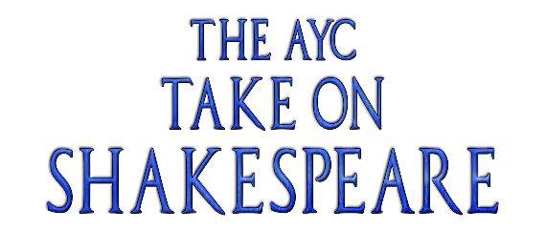
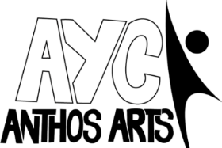
The AYC Take on Shakespeare: Cast Details Form
Name:

Preferred Name/ Pronouns:

Date of Birth:

Parent/Guardian Names:

Contact Number:

Contact Email:

The spring term performance will be on Sunday 8th March. I know that I can be available for the whole of this day.

Rehearsals for spring term will take place on Saturdays from Saturday 3rd Jan to Sunday 8th March 2026. Please state any dates you are unable to make in the attached rehearsal schedule at the end of the form.

Rehearsals will be held 1-3pm at Emmanual Hall, Emmanual Road, St Thomas, Exeter, EX4 1EJ. The final performance will be held at the Cygnet Theatre, Exeter on Sunday 8th March 2026. Cast are required to be available for the entire day of the performance to allow for a technical rehearsal in the morning.
The total cost to be involved in the project is £110. If you have more than one child attending and would like to spread out the costs further, please speak to Emma (emma.anthos-arts@hotmail.com).
I agree to a payment of £110 for the full project. Payment via BACS to:

Anthos Arts
Account Number: 57329370
Sort Code: 600806

Please note, full payment must be made by Saturday 7th February 2026.
PLEASE USE CHILD’S NAME AS A REFERENCE ON ANY PAYMENT.
Permissions and Emergency Contacts:
As part of our safeguarding policy, Anthos Arts asks that parents of children and young people who attend our sessions have three emergency contacts whom we can contact in the event of an emergency. Participants under the age of 16 also require permission to leave rehearsals without being accompanied by an adult to travel home. Please fill out the boxes below.
I am happy for my child to leave rehearsals without being accompanied by a nominated adult:
YES/NO (please circle/delete as appropriate.)
I ….. hereby give my consent for the following individuals to collect my child/children on my behalf from sessions and events in my absence.

Signature: Date: 29/09/2024

Name of Nominated Person #1:
Contact Number:
Relation to Child:
Name of Nominated Person #2:
Contact Number:
Relation to Child:
Name of Nominated Person #3:
Contact Number:
Relation to Child:
Known Medical Information:
(Please list all known medical information in regard to your child/children attending the sessions. Our primary first aider during sessions is Jake Celecia.)

CONSENT:
I …………… hereby consent to any First Aid or medical treatment necessary to be given to my child/children ……………………………… during rehearsals. I authorise supervising staff to sign any written form of consent required by the hospital authorities if the delay in obtaining my signature is considered by the doctor to endanger my child’s health and safety.

Media and Publicity
A part of Anthos Arts’ new success has been our media attention. Please sign below to show that you are happy for us to photograph/video your child and that your child is allowed to be a part of any media used within our publicity.
I (parents/ guardians name)  ________  allow my child (child’s name)  _____  to be photographed and videoed for use by Anthos Arts publicity. | Parent/ guardians signature

SPRING TERM REHEARSALS
Please state any dates you are unable to make.
Saturday 3rd January 1-3pm

Saturday 10th January 1-3pm

Saturday 17th January 1-3pm

Saturday 24th January 1-3pm

Saturday 31st January 1-3pm

Saturday 7th February 1-3pm

Saturday 14th February 1-3pm

Saturday 21st February 1-3pm

Saturday 28th February 1-3pm

Saturday 7th March 1-4pm-
DRESS REHEARSAL

Sunday 8th March- 11am-6pm
PERFORMANCE DAY

Signed: Dated:

If there are any questions, then don’t hesitate to get in touch! Contact us with any queries you might have. Otherwise please return this completed form to applications.anthos-arts@outlook.com.
Thank you for completing this form. We look forward to working with you.
The Anthos Team.

